WEEK 4
TASK 1 :
Aim :
To determine whether the two halves of a given even-length string are alike by checking if both halves contain an equal number of vowels.
Algorithm:
- start
- Read the input string s.
- Find the midpoint of the string using mid = length / 2.
- Initialize two counters countA and countB to zero.
- Define a string containing all vowels (both uppercase and lowercase).
- Traverse from index 0 to mid - 1:
- If the character in the first half is a vowel, increment countA.
- If the corresponding character in the second half is a vowel, increment countB.
- Compare countA and countB.
- If both counts are equal, return true; otherwise, return false.
- stop
Program:
class Solution {
public boolean halvesAreAlike(String s) {
int mid = s.length() / 2;
int countA = 0, countB = 0;
String vowels = "aeiouAEIOU";
for (int i = 0; i < mid; i++) {
if (vowels.indexOf(s.charAt(i)) != -1) {
countA++;
}
if (vowels.indexOf(s.charAt(i + mid)) != -1) {
countB++;
}
}
return countA == countB;
}
}

Output:
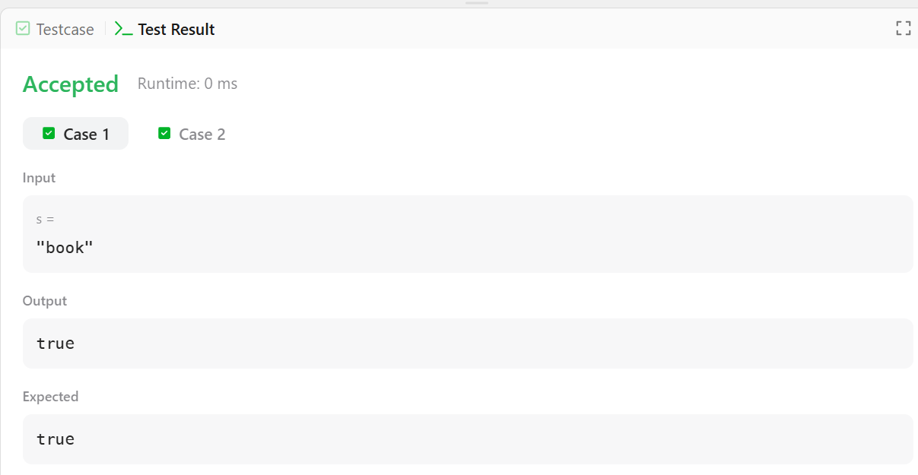
RESULT :
The program successfully determines whether both halves of the string have the same number of vowels and prints true or false accordingly.

Task2 :

Aim:

To check whether a given string is a lapindrome. A string is said to be a lapindrome if, after splitting it into two halves (ignoring the middle character if the length is odd), both halves contain the same characters with the same frequency.

Algorithm:
- Start.
- Read the number of test cases T.
- For each test case:
  - Read the string S.
  - Find the length n of the string.
  - Calculate the middle index mid = n / 2.
- Create two frequency arrays of size 26 (for lowercase English letters).
- Count the frequency of characters in the first half of the string.
- Count the frequency of characters in the second half of the string:
  - If the string length is odd, skip the middle character.
- Compare both frequency arrays:
  - If all frequencies match, the string is a lapindrome.
  - Otherwise, it is not a lapindrome.
- Print "YES" if the string is a lapindrome, else print "NO".
- Stop
Program :
import java.util.*;
import java.lang.*;
import java.io.*;
class Codechef {
public static void main (String[] args) throws java.lang.Exception {
Scanner sc = new Scanner(System.in);
int T = sc.nextInt();
while (T-- > 0) {
String s = sc.next();
int n = s.length();
int[] freq1 = new int[26];
int[] freq2 = new int[26];
int mid = n / 2;

for (int i = 0; i < mid; i++) {
freq1[s.charAt(i) - 'a']++;
}
for (int i = (n % 2 == 0 ? mid : mid + 1); i < n; i++) {
freq2[s.charAt(i) - 'a']++;
}
boolean isLapindrome = true;
for (int i = 0; i < 26; i++) {
if (freq1[i] != freq2[i]) {
isLapindrome = false;
break;
}
}
if (isLapindrome)
System.out.println("YES");
else
System.out.println("NO");
}
sc.close();
}
}

Output:

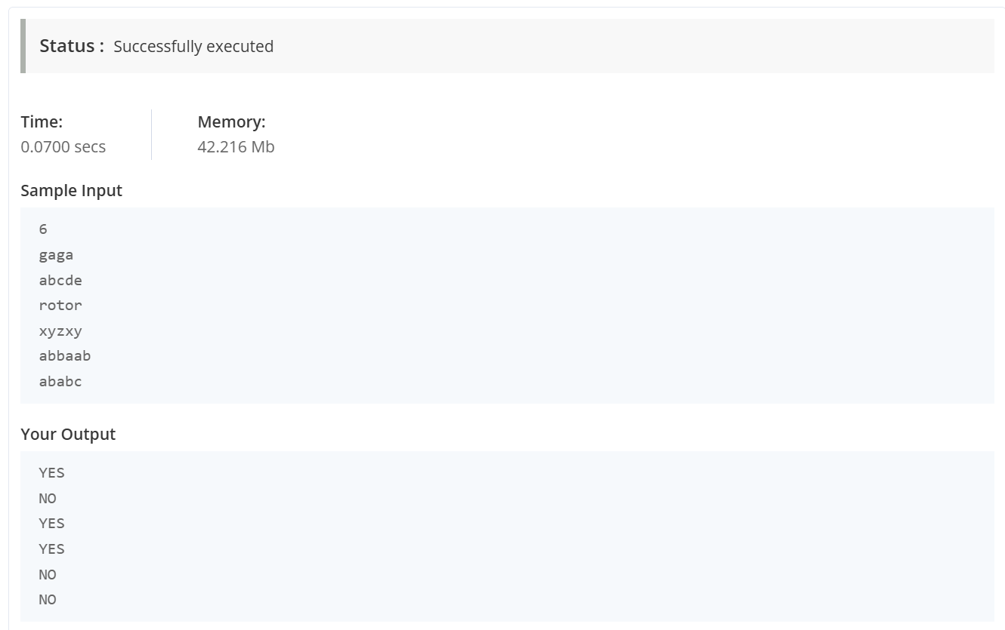

Result:

The program successfully identifies whether each given string is a lapindrome or not by comparing the character frequencies of its two halves and displays “YES” for lapindrome strings and “NO” for non-lapindrome strings.

TASK 3 :

AIM :

To compare two lists of integers (triplets) element by element and calculate the score of each list based on comparison rules.

ALGORITHM :
- Initialize two integer variables scoreA and scoreB to 0.
- Iterate through the elements of both lists a and b from index 0 to 2.
- For each index:
- If a[i] > b[i], increment scoreA by 1.
- If a[i] < b[i], increment scoreB by 1.
- If a[i] == b[i], do nothing.
- Store scoreA and scoreB in a list.
- Return the list containing the final scores.

PROGRAM :

public class Solution {

public static void main(String[] args) throws IOException {

BufferedReader bufferedReader = new BufferedReader(new InputStreamReader(System.in));

BufferedWriter bufferedWriter = new BufferedWriter(new FileWriter(System.getenv("OUTPUT_PATH")));

List<Integer> a = Stream.of(bufferedReader.readLine().replaceAll("\\s+$", "").split(" "))

.map(Integer::parseInt)

.collect(toList());

List<Integer> b = Stream.of(bufferedReader.readLine().replaceAll("\\s+$", "").split(" "))

.map(Integer::parseInt)

.collect(toList());

List<Integer> result = Result.compareTriplets(a, b);

bufferedWriter.write(

result.stream()

.map(Object::toString)

.collect(joining(" "))

+ "\n"

);

bufferedReader.close();

bufferedWriter.close();

}

}

OUTPUT :

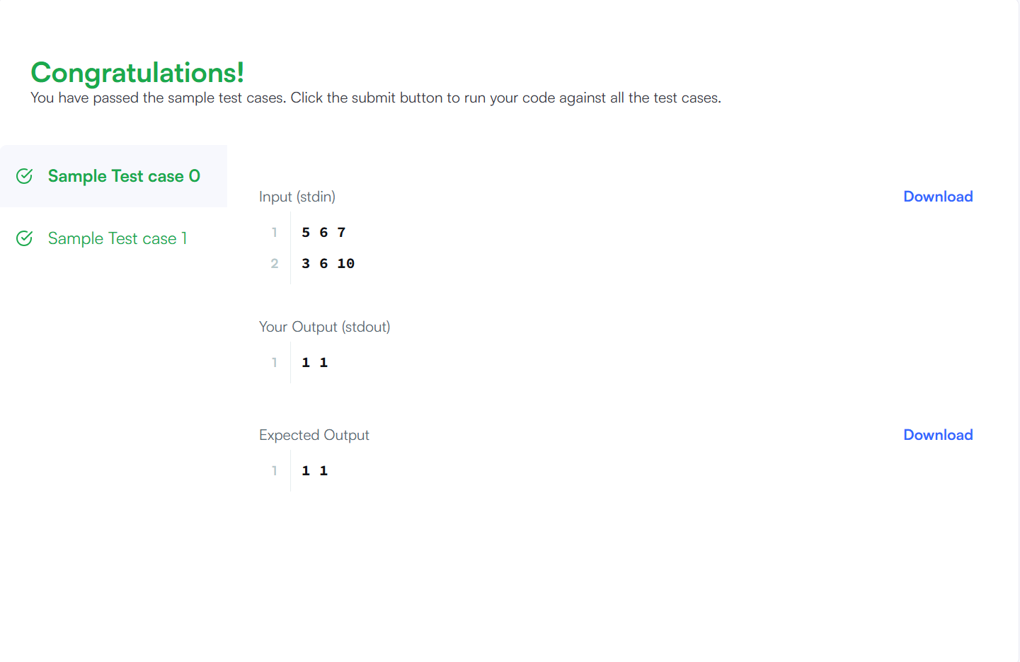

RESULT :

The program successfully compares the two triplets and outputs the final scores of both participants as an integer list.

AIM : 4

To check whether an integer array contains any duplicate elements.

ALGORITHM:
- Create an empty HashSet to store visited elements.
- Traverse each element in the given array.
- Check if the element already exists in the HashSet.
- If it exists, return true (duplicate found).
- If it does not exist, add the element to the HashSet.
- If the loop completes without finding duplicates, return false.

PROGRAM :

import java.util.HashSet;

class Solution {

public boolean containsDuplicate(int[] nums) {

HashSet<Integer> seen = new HashSet<>();

for (int num : nums) {

if (seen.contains(num)) {

return true;

}

seen.add(num);

}

return false;

}

}

public class Main {

public static void main(String[] args) {

Solution sol = new Solution();

int[] nums1 = {1, 2, 3, 1};

int[] nums2 = {1, 2, 3, 4};

int[] nums3 = {1, 1, 1, 3, 3, 4, 3, 2, 4, 2};

System.out.println(sol.containsDuplicate(nums1));

System.out.println(sol.containsDuplicate(nums2));

System.out.println(sol.containsDuplicate(nums3));

}

}

OUTPUT :

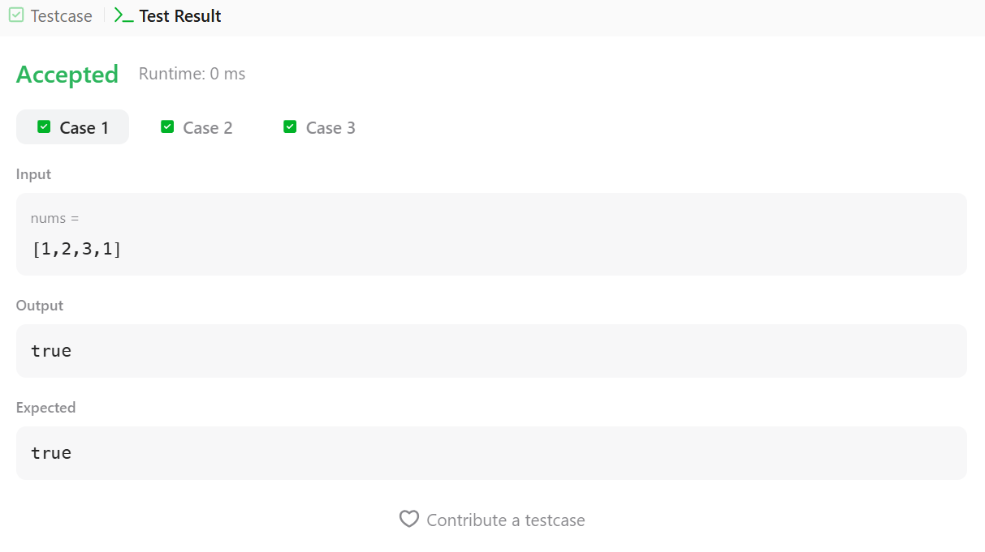

RESULT :

The program correctly identifies arrays with duplicate values and prints true if duplicates exist, otherwise prints false.

TASK 5:

AIM :

To convert a given time from 12-hour AM/PM format into 24-hour (military) time format.

ALGORITHM:
- Read the input time string in 12-hour format.
- Extract the hour part, minutes–seconds part, and AM/PM indicator.
- If the time is AM and the hour is 12, change the hour to 00.
- If the time is PM and the hour is not 12, add 12 to the hour.
- Format the hour to two digits and combine it with minutes and seconds.
- Display the converted 24-hour time.

PROGRAM :

import java.util.Scanner;

public class Solution {

public static String timeConversion(String s) {

String ampm = s.substring(8); // "AM" or "PM"

int hour = Integer.parseInt(s.substring(0, 2));

String minutesSeconds = s.substring(2, 8); // ":MM:SS"

if (ampm.equals("AM")) {

if (hour == 12) {

hour = 0; // midnight case

}

} else { // PM case

if (hour != 12) {

hour += 12; // add 12 for afternoon/evening

}

String hourStr = String.format("%02d", hour);

return hourStr + minutesSeconds;

}

public static void main(String[] args) {

Scanner sc = new Scanner(System.in);

String s = sc.nextLine(); // read input string

System.out.println(timeConversion(s));

sc.close();

}

}

OUTPUT :

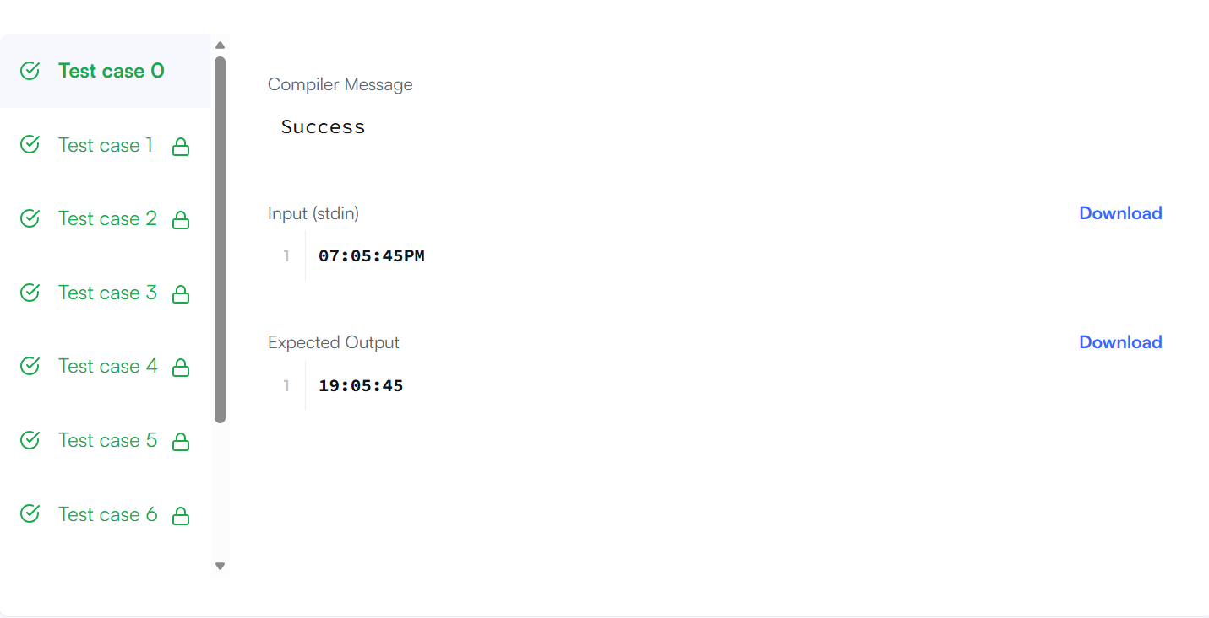

RESULT :

The program successfully converts the given 12-hour format time into its equivalent 24-hour format and prints the result.

TASK 6 :

AIM :

To move all zero elements in the given array to the end while maintaining the relative order of non-zero elements.

ALGORITHM:
- Initialize a pointer j to 0 to track the position of non-zero elements.
- Traverse the array using index i.
- If nums[i] is not zero, swap it with nums[j].
- Increment j after each swap.
- Continue until all elements are processed.

PROGRAM :

class Solution {

public void moveZeroes(int[] nums) {

int j = 0;

for (int i = 0; i < nums.length; i++) {

if (nums[i] != 0) {

int temp = nums[i];

nums[i] = nums[j];

nums[j] = temp;

j++;

}

}

}

}

OUT PUT :

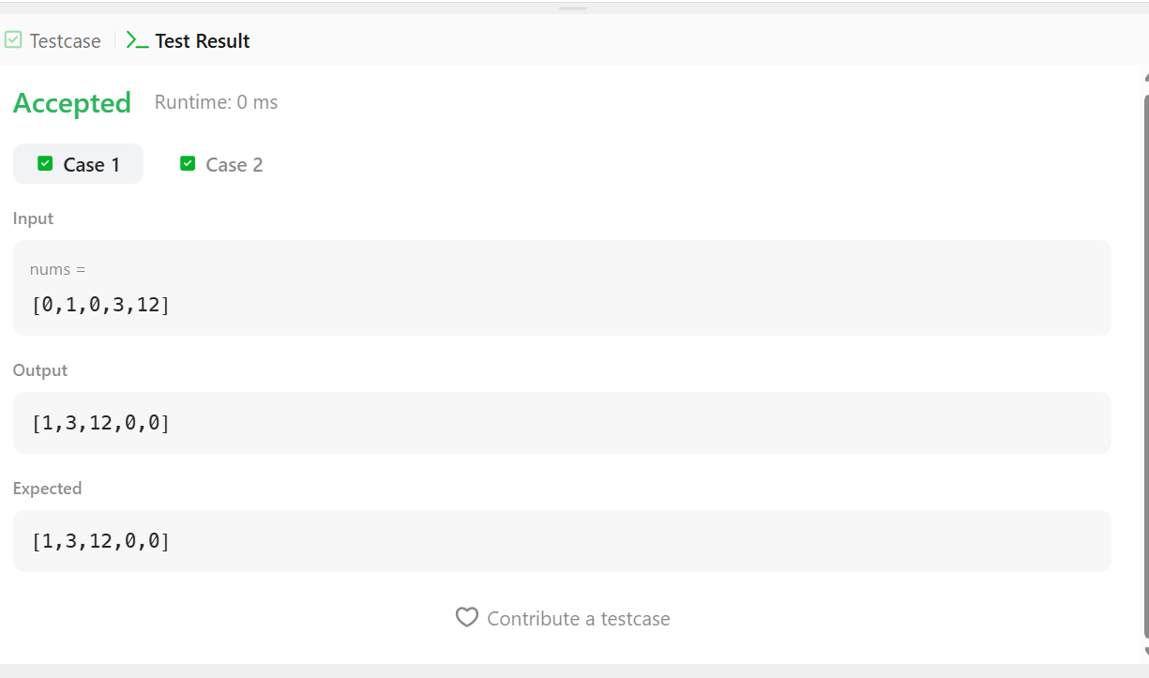

RESULT :

The program rearranges the array by shifting all zero values to the end and keeps the order of non-zero elements unchanged.

TASK 7 :

AIM:
To calculate the absolute difference between the sums of the primary and secondary diagonals of a square matrix.

ALGORITHM:
- Read the size n of the square matrix and its elements.
- Initialize two variables to store the sums of the primary and secondary diagonals.
- Traverse the matrix using a single loop.
- Add elements arr[i][i] to the primary diagonal sum.
- Add elements arr[i][n − i − 1] to the secondary diagonal sum.
- Find and return the absolute difference between the two sums.

PROGRAM :

import java.util.Scanner;

public class Solution {

public static int diagonalDifference(int[][] arr) {

int n = arr.length;

int primaryDiagonal = 0;

int secondaryDiagonal = 0;

for (int i = 0; i < n; i++) {

primaryDiagonal += arr[i][i];

secondaryDiagonal += arr[i][n - i - 1];

}

return Math.abs(primaryDiagonal - secondaryDiagonal);

}

public static void main(String[] args) {

Scanner sc = new Scanner(System.in);

int n = sc.nextInt(); // size of matrix

int[][] arr = new int[n][n];

for (int i = 0; i < n; i++) {

for (int j = 0; j < n; j++) {

arr[i][j] = sc.nextInt();

}

}

System.out.println(diagonalDifference(arr));

sc.close();

}

}

OUTPUT :



RESULT:
The program successfully computes and displays the absolute difference between the sums of the two diagonals of the given square matrix.

TASK 8 :

AIM:
To find the transpose of a given matrix by converting rows into columns.

ALGORITHM:
- Read the number of rows m and columns n of the matrix.
- Create a new matrix of size n × m to store the transpose.
- Traverse the original matrix using nested loops.
- Assign each element matrix[i][j] to result[j][i].
- After completing the traversal, return the transposed matrix.

PROGRAM :

class Solution {

public int[][] transpose(int[][] matrix) {

int m = matrix.length;

int n = matrix[0].length;

int[][] result = new int[n][m];

for (int i = 0; i < m; i++) {

for (int j = 0; j < n; j++) {

result[j][i] = matrix[i][j];

}

}

return result;

}

public static void main(String[] args) {

Solution sol = new Solution();

int[][] matrix1 = {{1,2,3},{4,5,6},{7,8,9}};

int[][] matrix2 = {{1,2,3},{4,5,6}};

int[][] result1 = sol.transpose(matrix1);

int[][] result2 = sol.transpose(matrix2);

printMatrix(result1); // [[1,4,7],[2,5,8],[3,6,9]]

printMatrix(result2); // [[1,4],[2,5],[3,6]]

}

private static void printMatrix(int[][] matrix) {

for (int[] row : matrix) {

for (int val : row) {

System.out.print(val + " ");

}

System.out.println();

}

}

}

OUTPUT :

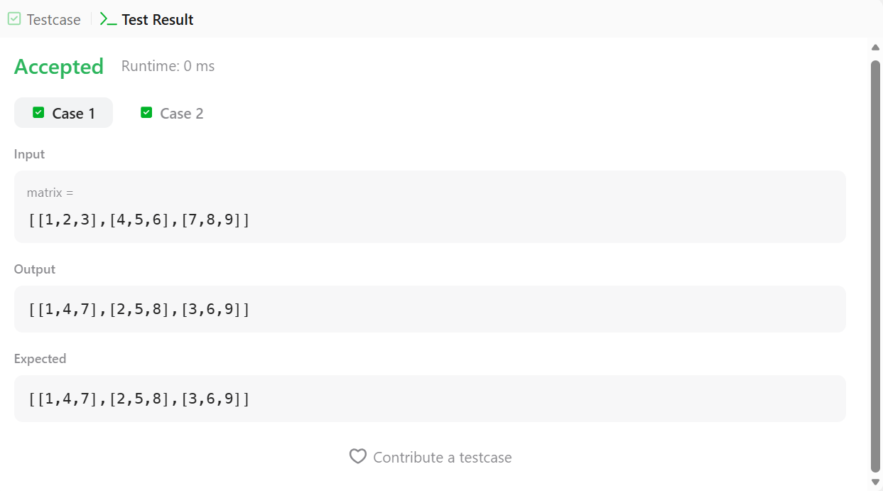

RESULT :

The program successfully computes and displays the transpose of the given matrix, where rows are converted into columns and columns into rows.

TASK 9 :

AIM :

To compute the block sum for each element in a matrix using a given range k, where each block sum includes all elements within k distance from that element.

ALGORITHM:
- Read the matrix dimensions m and n.
- Create a prefix sum matrix of size (m+1) × (n+1).
- Compute prefix sums so that each cell stores the sum of elements from the top-left corner to that position.
- For each element in the original matrix, determine the top-left and bottom-right boundaries of the block using k.
- Use the prefix sum matrix to calculate the block sum efficiently.
- Store the computed block sum in the result matrix and return it.

PROGRAM :

class Solution {

public int[][] matrixBlockSum(int[][] mat, int k) {

int m = mat.length, n = mat[0].length;

int[][] prefix = new int[m+1][n+1];

for (int i=1; i<=m; i++) {

for (int j=1; j<=n; j++) {

prefix[i][j] = mat[i-1][j-1] + prefix[i-1][j] + prefix[i][j-1] - prefix[i-1][j-1];

}

}

int[][] ans = new int[m][n];

for (int i=0; i<m; i++) {

for (int j=0; j<n; j++) {

int r1 = Math.max(0, i-k), c1 = Math.max(0, j-k);

int r2 = Math.min(m-1, i+k), c2 = Math.min(n-1, j+k);

ans[i][j] = prefix[r2+1][c2+1] - prefix[r1][c2+1] - prefix[r2+1][c1] + prefix[r1][c1];

}

}

return ans;

}

}

OUTPUT :

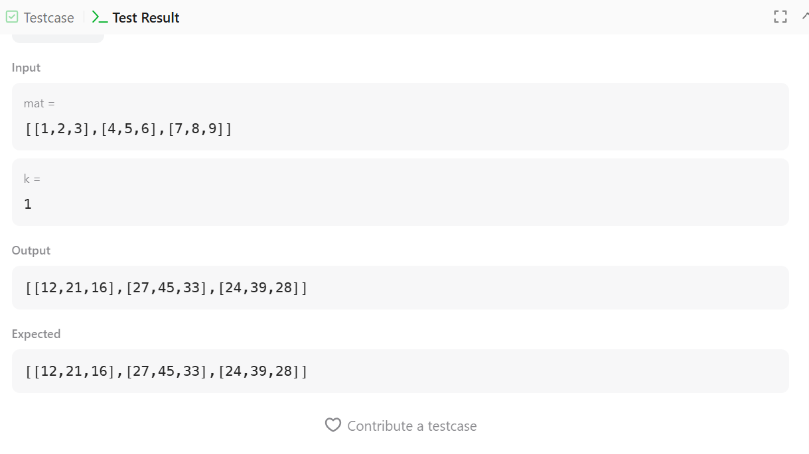

RESULT :

The program successfully calculates the block sum matrix, where each element represents the sum of all elements within distance k from the corresponding position in the original matrix.

TASK 10 :

AIM :

To rotate the elements of a given matrix anticlockwise by r rotations layer by layer.

ALGORITHM:
- Read the matrix dimensions m, n and the number of rotations r.
- Determine the number of layers in the matrix.
- For each layer, store its boundary elements in a list.
- Rotate the list by r positions using modulo operation.
- Place the rotated elements back into the matrix in the same layer order.
- Repeat for all layers.
- Display the final rotated matrix.

PROGRAM

import java.util.*;

public class Solution {

public static void matrixRotation(int[][] matrix, int r) {

int m = matrix.length;

int n = matrix[0].length;

int layers = Math.min(m, n) / 2;

for (int layer = 0; layer < layers; layer++) {

List<Integer> elements = new ArrayList<>();

for (int j = layer; j < n - layer; j++) {

elements.add(matrix[layer][j]);

}

for (int i = layer + 1; i < m - layer - 1; i++) {

elements.add(matrix[i][n - layer - 1]);

}

for (int j = n - layer - 1; j >= layer; j--) {

elements.add(matrix[m - layer - 1][j]);

}

for (int i = m - layer - 2; i > layer; i--) {

elements.add(matrix[i][layer]);

}

int len = elements.size();

int rot = r % len;

List<Integer> rotated = new ArrayList<>();

rotated.addAll(elements.subList(rot, len));

rotated.addAll(elements.subList(0, rot));

int idx = 0;

for (int j = layer; j < n - layer; j++) {

matrix[layer][j] = rotated.get(idx++);

}

for (int i = layer + 1; i < m - layer - 1; i++) {

matrix[i][n - layer - 1] = rotated.get(idx++);

}

for (int j = n - layer - 1; j >= layer; j--) {

matrix[m - layer - 1][j] = rotated.get(idx++);

}

for (int i = m - layer - 2; i > layer; i--) {

matrix[i][layer] = rotated.get(idx++);

}

}

for (int i = 0; i < m; i++) {

for (int j = 0; j < n; j++) {

System.out.print(matrix[i][j] + " ");

}

System.out.println();

}

}

public static void main(String[] args) {

Scanner sc = new Scanner(System.in);

int m = sc.nextInt();

int n = sc.nextInt();

int r = sc.nextInt();

int[][] matrix = new int[m][n];

for (int i = 0; i < m; i++) {

for (int j = 0; j < n; j++) {

matrix[i][j] = sc.nextInt();

}

}

matrixRotation(matrix, r);

sc.close();

}

}

OUTPUT :

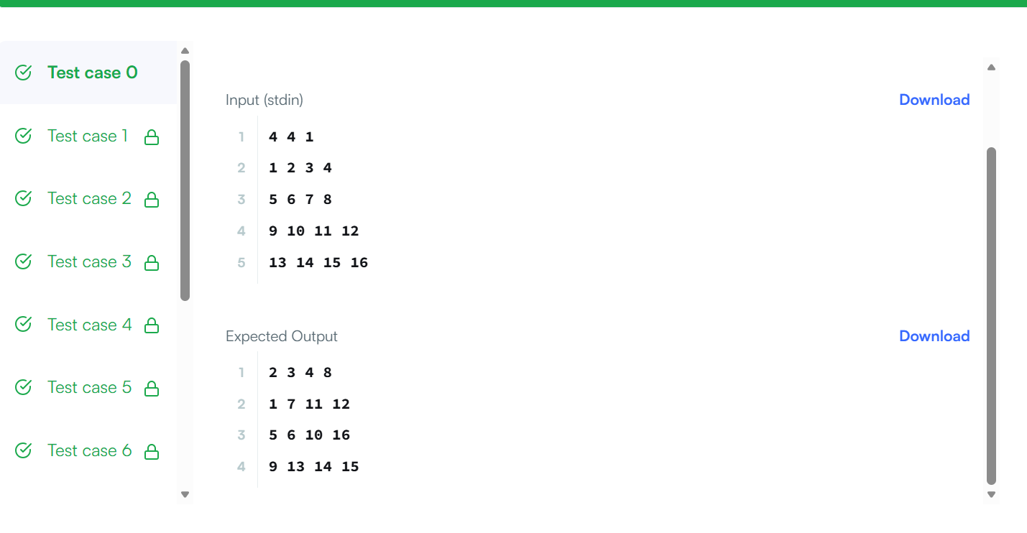

RESULT :

The program successfully rotates the given matrix anticlockwise by the specified number of rotations and prints the updated matrix.

